copy activity \
source – one linked service and one datset – we create parameters and pass them dynamically at dataset level so tht we don’t hardcode file names and it was taken at run time directly
sink - one linked service and one datset – we create parameters and pass them dynamically at dataset level so tht we don’t hardcode file names and it was taken at run time directly
now We use Get metadata activity (here we need to check destintion folder inside container in ADLS ) to chck the array given by GET META and loop over it an using IF else activity we only load table names starting with Fact*
we need to use @acitivity(‘Get metadata’).output.childitems inside for loop dynamic content --- inside for each we need to add IF Activity and here we need to add dynamic content by writing item().name (here Item() is iterator I in for loop)
Get metadata-this will bring everything and we need to loop over the array given by metadata---Foreach Activity inside we need to add dynamicbecause we get everything from GMD but we need childitems so like that((@acitivity(‘Get metadata’).output.childitems)) -- inside foreach we need to bring IF activity and get item().name provided by foreach -- now we need to give condition where our item name should start with Fact- so we need to use built in functions provided bottom- and so we need startswith(item().name,’Fact’) -- this is give our required output-- If our condition is true we need to give some action right so again we go inside true condition and get COPY Activity and give source and sink
Inside IF condition we need to go to TRUE and declare activities again here if our condition satisfies we need to copy fact files in Destination folder in source dataset to our sink ( reporting folder)
for that to happen we need to pass dynamically our parameters at file level
so we can create P_FILE name and @dataset().P_fileName. Now this dataset is inside copy activity right so we get this reflected in copy activity as
Name Value
P_filename item().name ( but added dynamically)
now come to sink and do same as source
so we can create P_FILE name and @dataset().P_fileName. Now this dataset is inside copy activity right so we get this reflected in copy activity as
Name Value
P_filename item().name ( but added dynamically)
now we need to click on Debug and see only files with name start with fact go to reporting folder
now once we have data In reporting container we bring DATA FLOW activity (transformation )-Dataflow run spark behind the scenes ( we can do group by, sort and all )
We name the DATA FLOW activity as DATA Transformation and we need to attach data flow but we don’t have it so we need to go to settings and it will open data flow canvas and ask to give a name to it ( TransformCSV), we need to attach the source
now we need to give a name to source and add dataset to it ( here we add reporting container and go dynamically towards files ) and then we don’t care about source options and in projection we turn on Dataflow debug debug time to live – 1 hour ( this keeps our cluster running for one hour) and now we had a button IMPORT PROJECTION and it will import our data along with schema and there is an option called schema drift where Dataflow will decide the schematype ( mergeschema = true is in spark where spark decides our schema )
transacrtion id
transaction date
product id
customer id
payment
creditcard Number
now we add a + button at source
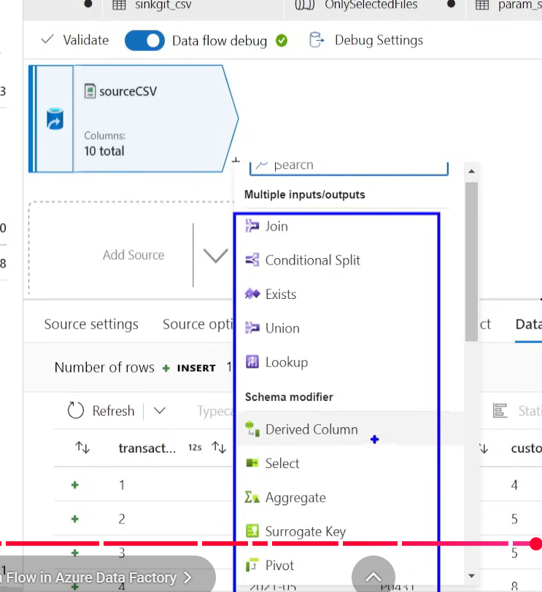
after get metdata activity --- for each – if – true – copy activity – source – sink --- reporting container ---//// get connect to data flow activity --
Dataflow – inside this we go again – source – select ( in select we had an option we
check on 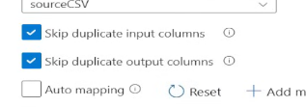 this is where we can skip duplicate input columns and o/p columns ----we can manually select required columns ----- filter - filter on = customer_id != 12 - Conditonal split----now we get DAG split into 2,3,4,5, as per our requirement
stream name Condition
visa payment == ‘visa’
master payment == ‘master
Amex all other
comes under this
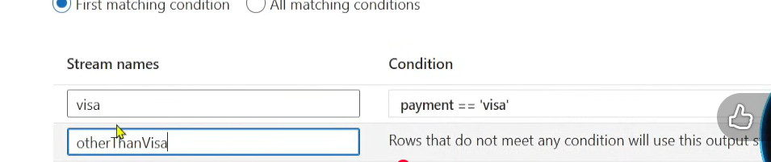
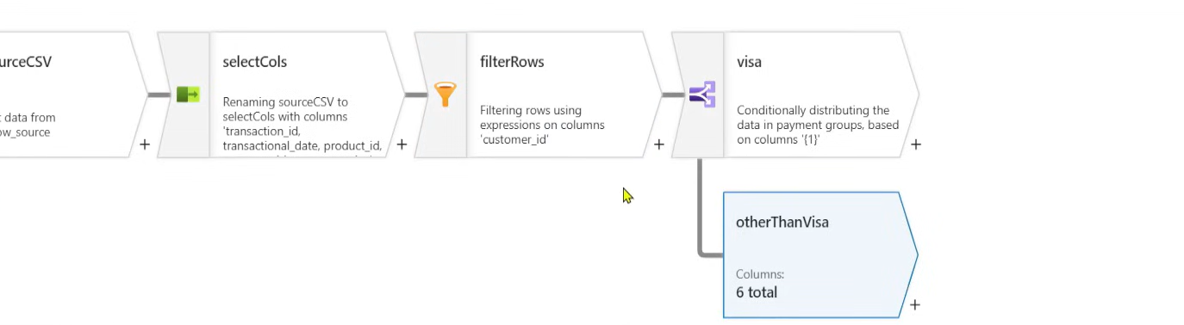
we get flow like this but we have three (visa,master,amex)
now in amex we need to remove nulls, we can do it by adding derived columns ( here coalesce(payment,’n/a’) or we can add a new column also (same as with column in spark)
now in visa we need to perform Group BY and for that we need to add aggregate button
source>select>filter>conditionalsplit>visa>aggregate(group by )
>master
>amex> derived columns ((coalesce(payment,’n/a’))
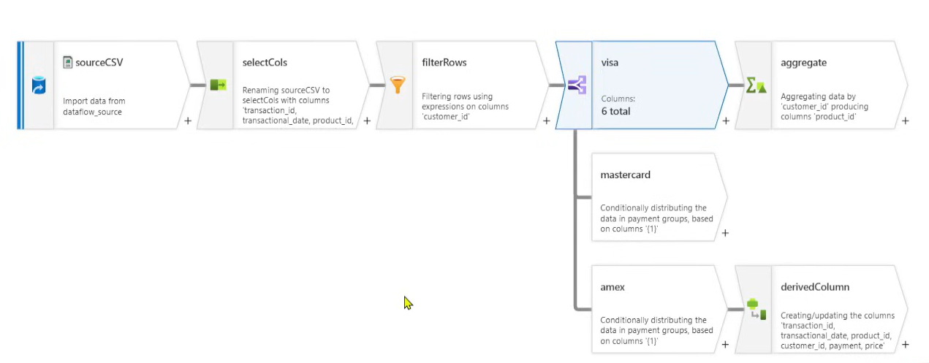
AGGREGATE--max of TXN AMOUNT and group by is Customer ID
next Alter rows---here we give a condition (1==1) and this condition will always become true so next Sink to adls location, we use alter because we are declaring that upsert can happen on this output at any point of time
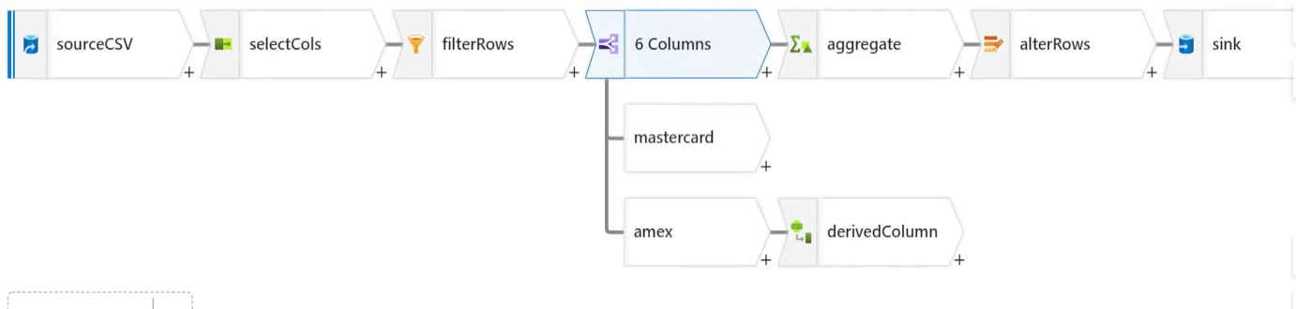
we need to publish all now in our canvas and then click on trigger and create a trigger
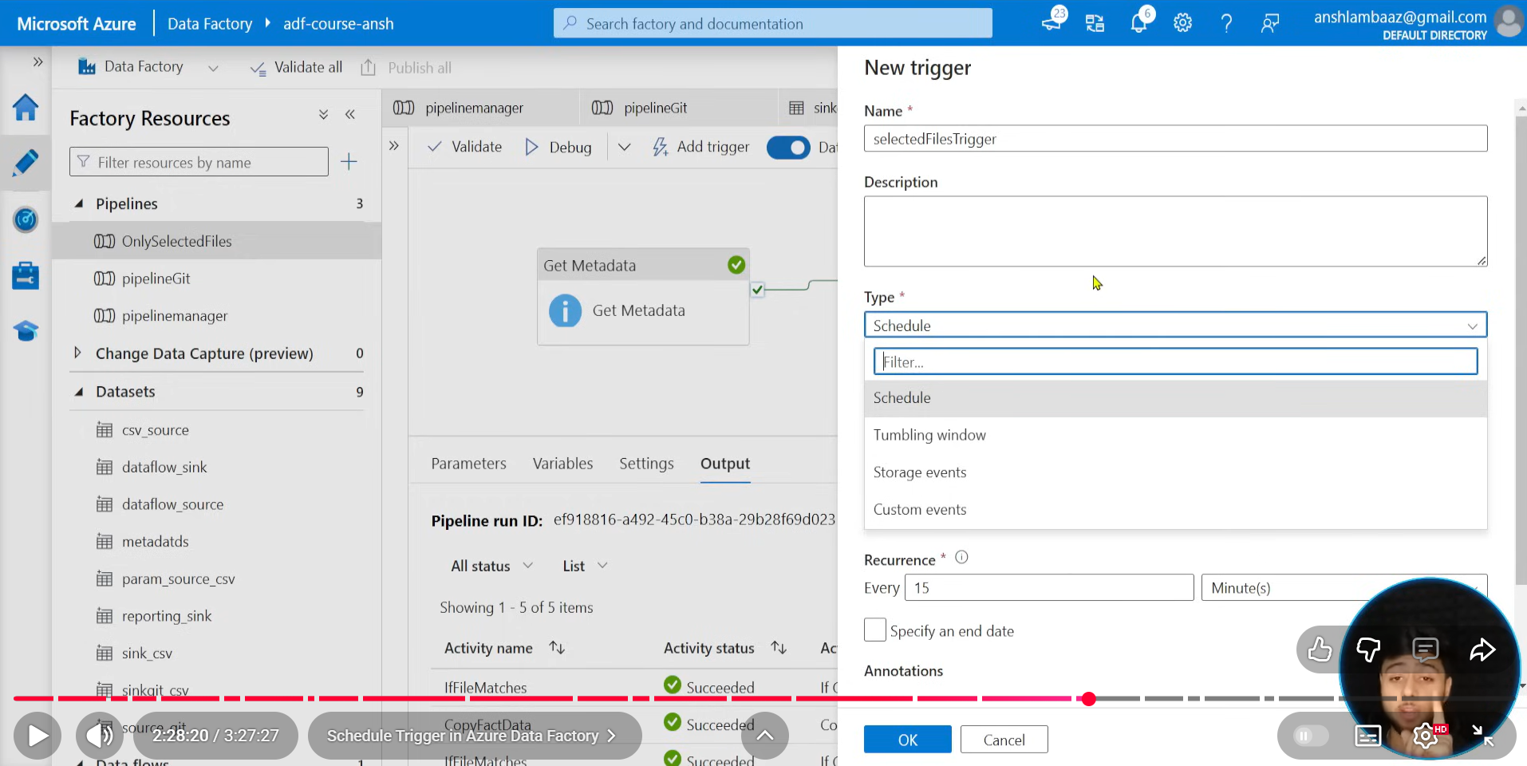
we need to use schedule trigger for present and future dates but tumbling window is used for past dates as well
and recurrence is evry 15minutes and UTC(Atlantic time zone)
======================================================================
now We go to SET VARIABLE ACTIVITY
copy paste the GET META DATA one from our previous pipeline and use it here
and bring set variable
we need to create a var_files varible at first by clicking on plain canvas and now in SET VARIABLE we get the name created earlier in settings > pipeline variables
now pipeline return value is allowed to use this O/p in other pipeline
in value we need to give GETMETADATAACTIVITY.CHILDITEMS()
getmetadata>setvariable> this is store child list in setvariables
===================================================================
storage event trigger:
we need to use copy activity from any source to sink and add trigger>storage event
full file path we need to give
once any files comes into that path our pipelines start running after that our file should be deleted in that container using delete ACTIVITY
we need to register Microsoft.eventgrid in azure subscription to use this event trigger
only name.csv if we define in blob start path then only that file is moved from one container to another and then delet the name.csv in source container
----------------------------------------------------------------------------------------
execute pipeline activity
one execute pipeline will call another pipeline we already built and 2nd execute pipeline will also call another pipeline
we can add execute pipeline inside our child pipeline as well where can call another pipeline beside activities
=================================================================
-===========================================================
+=================================
Azure SQL DB
we need to create source.orders
-
last_updated DATETIME DEFAULT GETDATE()
insert values
-
OUR TABLE HAS LASTUPDATED COLUMN
In containers we need to add a json file
{“cdc_timestamp”:”1900-01-01”}
linked servies:
create linked service with ADLS gen2 (ls_datalake)
create linked service with SQL DB (ls_database)
dataset:
create dataset for linked service – ls_datalake – path – source/monitor/csc.json
create dataset
in adflookuphere we get output of json as
{ count : 1
value: [{“cdc_timestamp”:”1900-01-01”}]
we need to create a variable test on canvas and then use set variable and map this variable to that
here we need to feed lookpup output as input value for this @activity(‘last_Cdc’).output.value[0].cdc_timestamp
((in getMETEDATAWe can get shchema of our data not all the data like how we got in LOOKUP. Here we need to use @activity(‘getmetadata’).output.Childtems[0].))
in SET VARIABLE we can see {name : “test”, “value”:1900-01-01”} -- we not using this now
After lookup copy activitysource (sql database )(ds_database)
IN DATASET FOR SQL DB – we have table,query,stored procedure (these appear In copy activity)
???we see start time and endtime in dataset when we see getmetadata getting child items or last modified date and the input parameters will change as per dataset we are linking
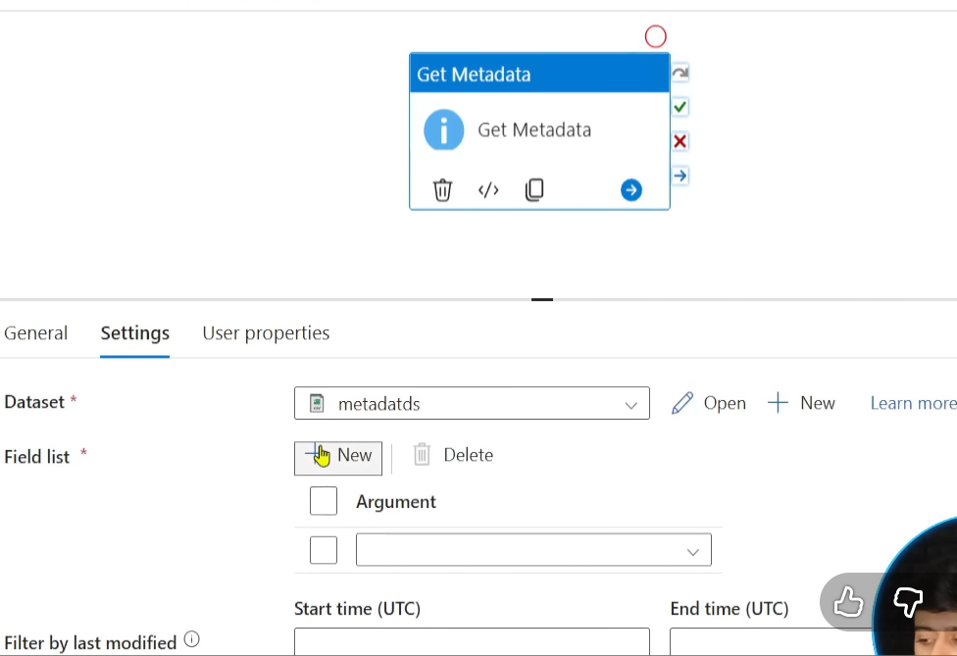
we use query
we create parameters
schema - source
table - orders
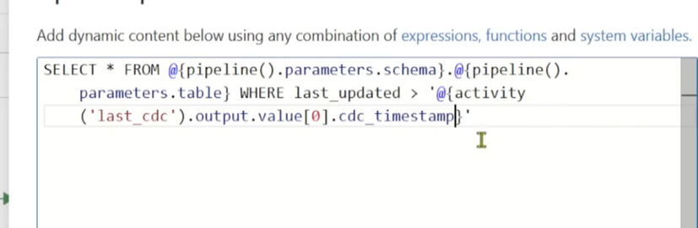
here source is AZURE DB and sink is ADLS – sink – parquet
we use last updated column from AZURE DB and compare it with load time in Json in ADLS
where lastupdated>(our lookup activity output)
---------------------------
we bring script activity and give same sql query here and use it
lookup>script for script(ls_database) is the linked service
here in script we use count(*) as total_count and the same sql query
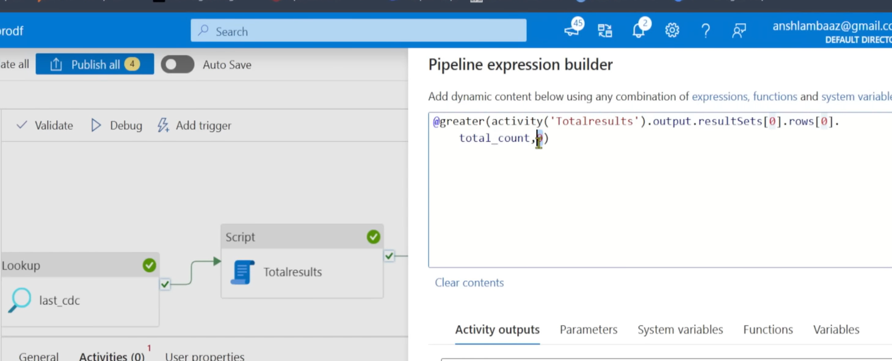
Here we are doing this because only if count>0 then we should run our pipeline right so We bring IF ACTIVITY and write a condition as per SS. Then true and cut paste that copy activity inside true branch
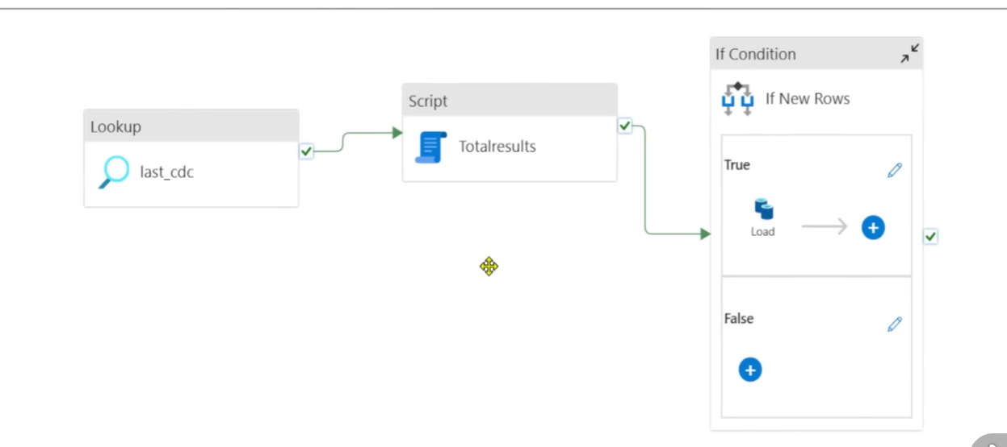
Here again inside true branch we had already a copy activity and now we bring one more copy activity and a script that uses max(last_update)
we should give source as empty json for that new copy activity and the source will take dynamic content as max(lastupdated) as per below SS
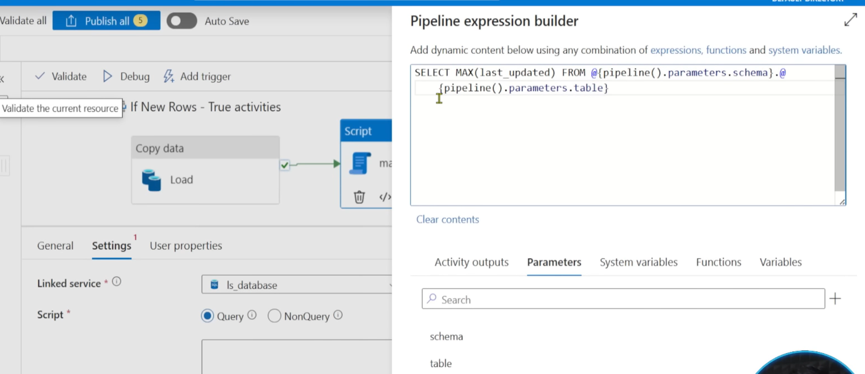
here we should give dynamic value for source in copy activity like this( the output of script and input to source)
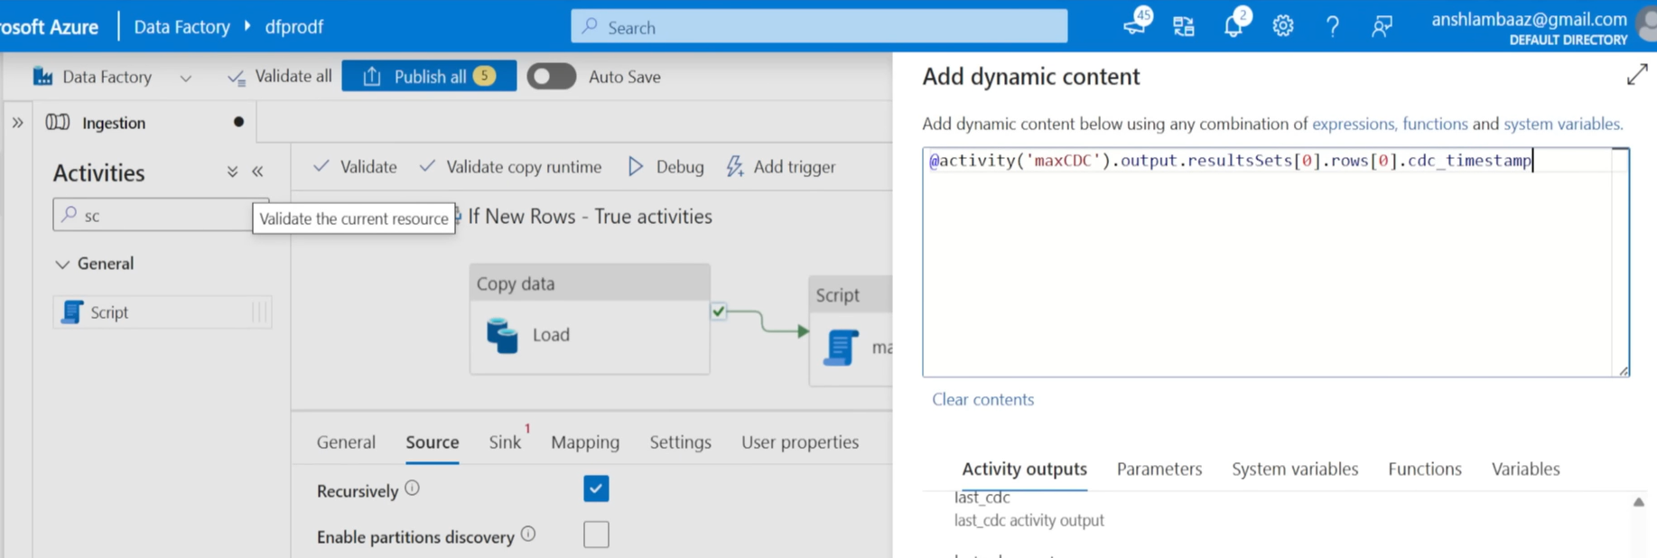
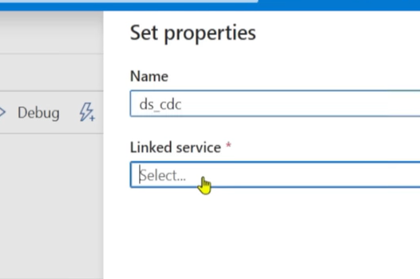
this DS_CDC is dataset used for lookup at start with 1900-01-01
now the sink is DS_CDC in copy activity so that this will be copied as a new row
we used a lookup activity for 1900-01-01 from ADLS and now look up will have { count : 1
value: [{“cdc_timestamp”:”1900-01-01”}]
We bring copy activity and now here we can say
this will get as source as SQL DB dataset and we get select * from schemaname.dbname where last_updated>@(activity(last_cdc).output.value[0].cdc_timestamp
and our sink is sink in ADLS container sink>orders> and this should not run even though there is no new modifications right so we count the last updated columns > lookup output ( that is our 1900-01-01 and this timestamp will change after each pipeline run )
but we use script and here source is LS_DATABase meaning azure DB count the last_updated columns using query option(we get output of sql)
there is non query option(DDL)
in query we get count of the last updated columns > lookup output as total_count
resultsets[0].rows[0].totalcount
we use IF condtion where @greater(out script output ,0)
then TRUE - in side true we can use our copy activity where we found new records and that should be copied to sink>order>
now we should update the json date (from 1900 to pipeline run time)
we need to change CDC,json so that we pass an empty json and add this to existing Cdc_JSON
we create a script and give CDC_TIMESTAMP to source of copy activity
In script we get max(last_updated) in our azure DB this value is feeded to copy activity empty json as source and sink is DS_CDC where it was 1900 previously
--------------------------------------____________________+++++++++++++++++++++++
NOW we are giving users flexibility to have back data refresh
we add a new parameter in our canvas
backdate ----------------empty(value)
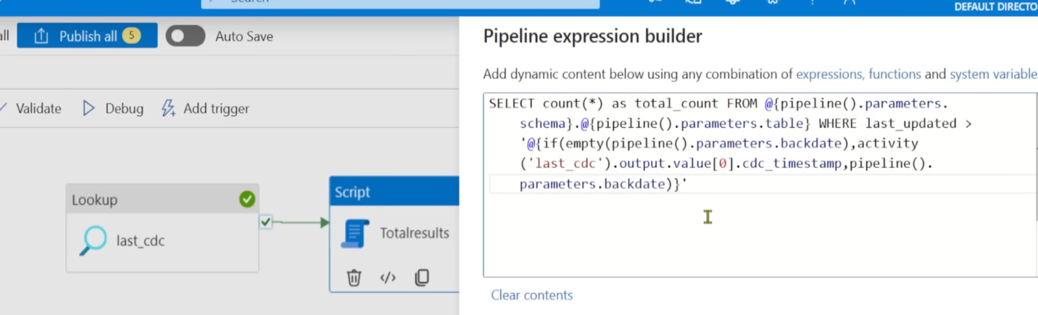
We can @{if(empty(backdate) then go for normal approach that is output of our lookup activity or else use backdate
then IF Condition is again to check @greater >0 count from the output of script
after load will be same We can @{if(empty(backdate) then go for normal approach that is output of our lookup activity or else use backdate but no need to count just select * from ……
we can load data from the date we can custom like 2025-09-09 but we get data where last updated in source column is greater than 2025-09-09
------------------------------
we create a new pipeline – execute pipeline and then use invoked pipeline INGESTION and publish all
we can create logic apps
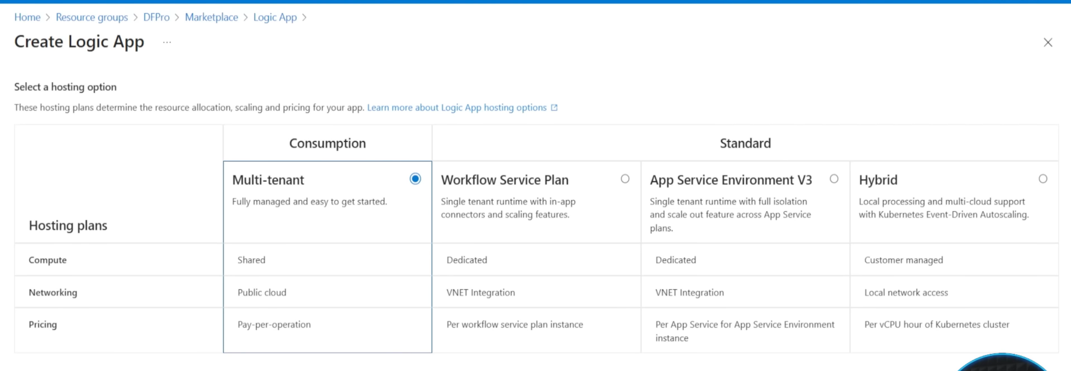
logicapp>multitenant>logic app designer>add a trigger >requests>when An HTTP request is received >here we need to write the json message we need to receive> send an email(v2) outlook one >
to :
Subject:
body
here are the details: click on tunder button on left
and add those variables we ceated in HTTP request
pipeline name :
pipeline run id :
now come to our ADF Canvas and then bring WEB activity and use that url given by logic apps and pass the execute pipeline activity on failure
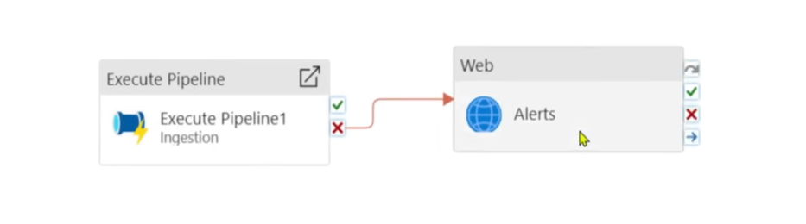
Inside this we pass values dynamically like pipeline name : @pipeline name from below functions
pipeline run id : @pipeline run id from below functions
We can create parameters on pipeline run time level also
we create parameter names and dynamic add that to variables
this we add to change values dynamically in the trigger
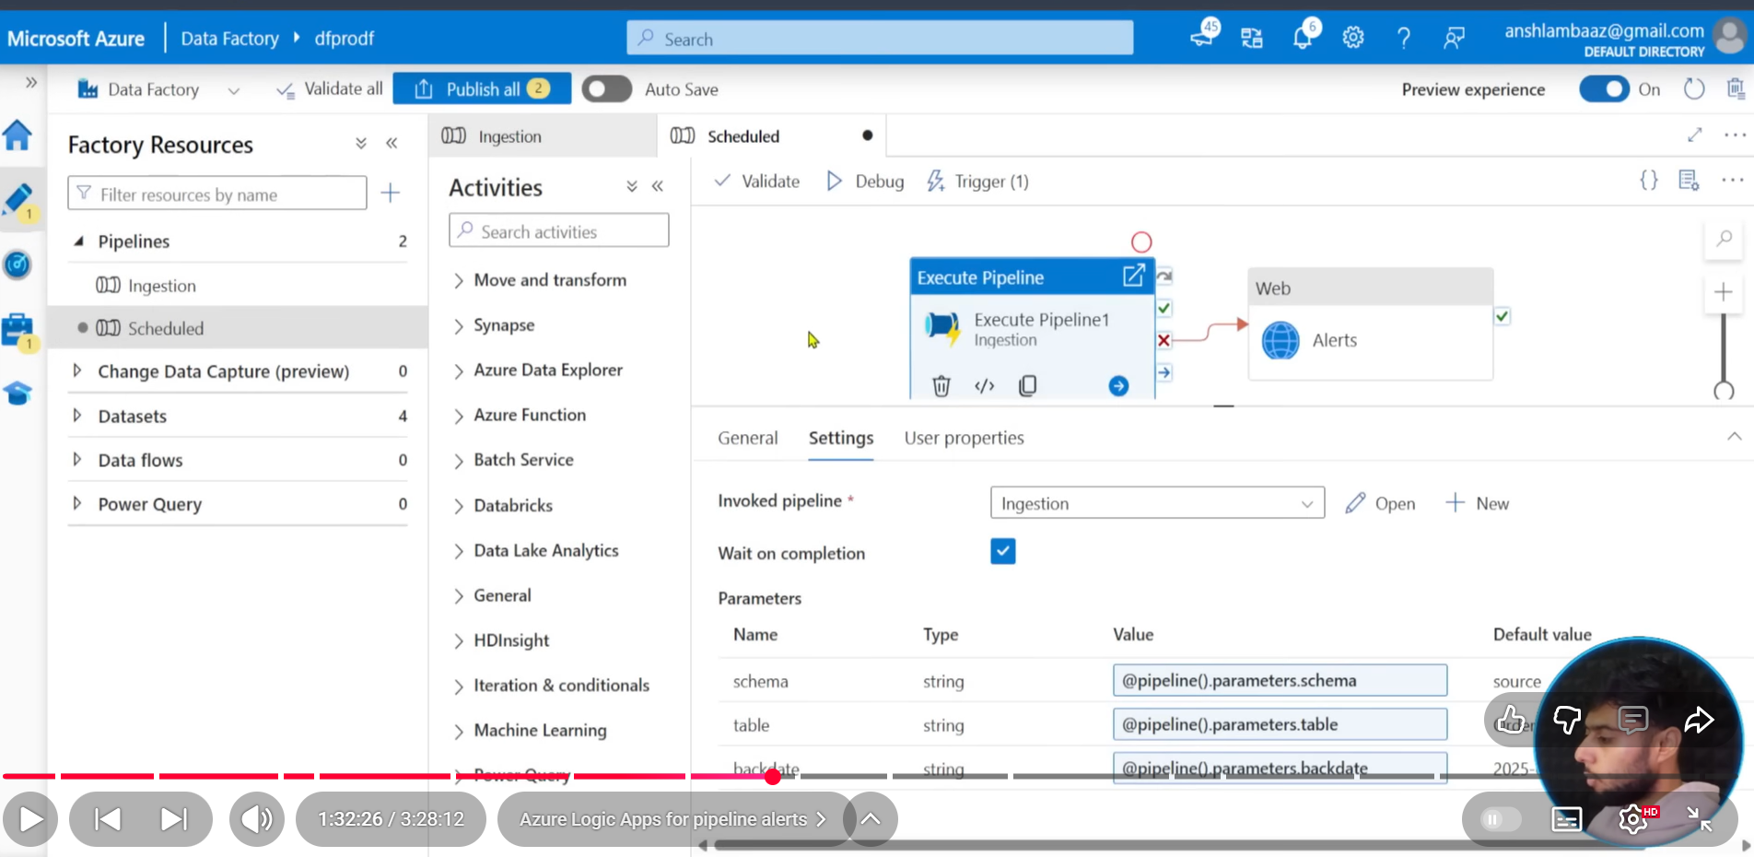
--------------------------------------------------------------------------------------------------------------
- to call data frm git hub using base url and relative url
web activity to check data – then use copy data> source> restAPI>pagination using absolute url
next in the body as per below ss
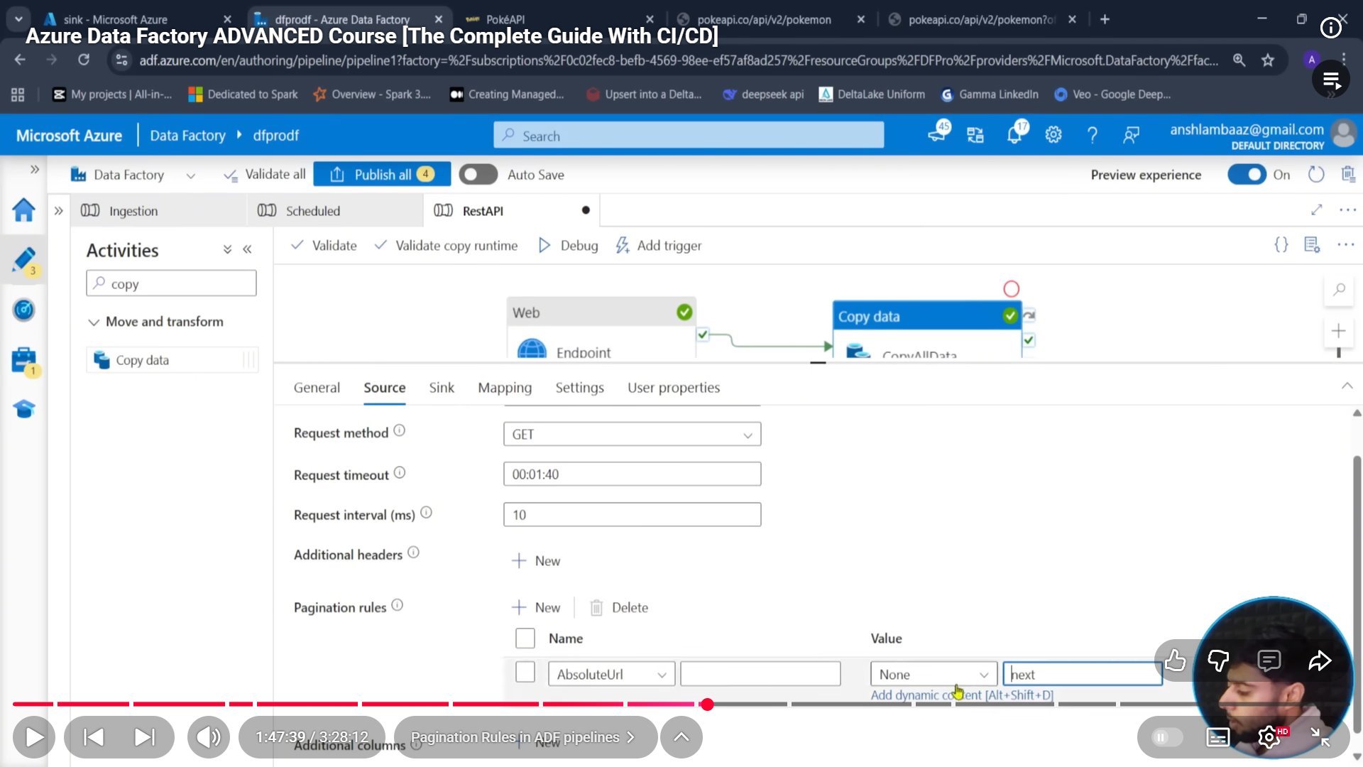
if next is not there then we can have offset=20
offset=40
here activity endpoint is like total count 1202 something like this
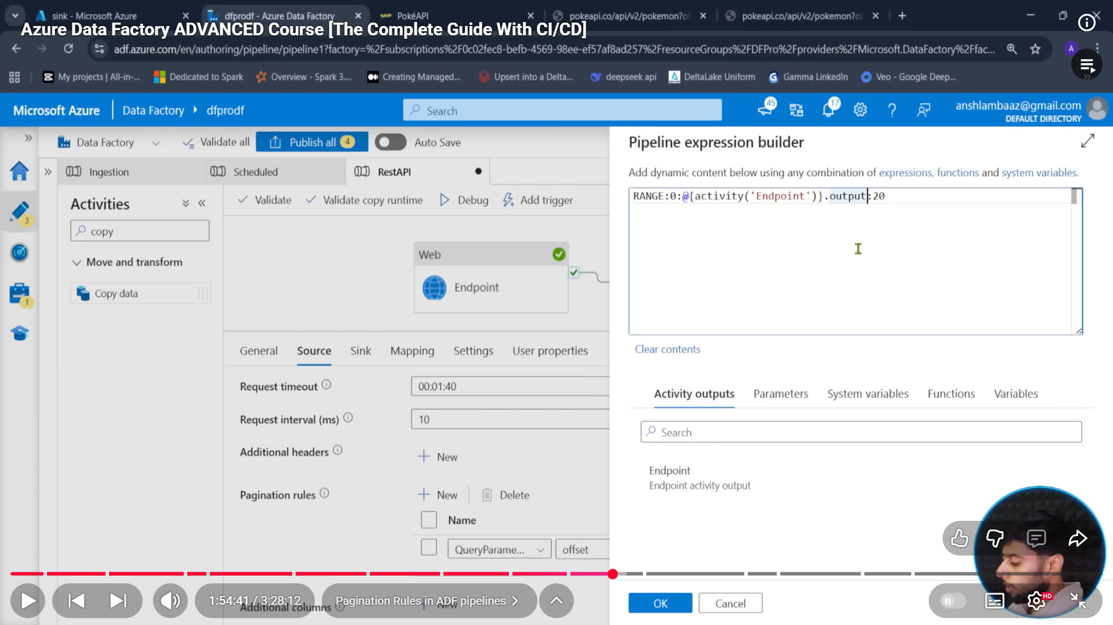
===================================================================
we use get meta data activity to get data from our ADLS
then foreach to loop over output
then switch to use item().name provided by foreach
inside switch we can add cases and assign activities to that again, pass values dynamically
now validate activity this is wait for particular file name to upload in the path we have given and will wait until then and run only after that file uploads
-----------------Strict schema enforcement
we need to make schema strict for that we need to add parameters and paste the code from import schema>code>translator
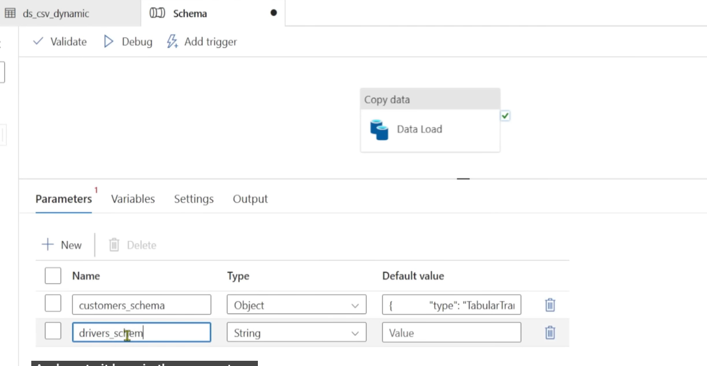
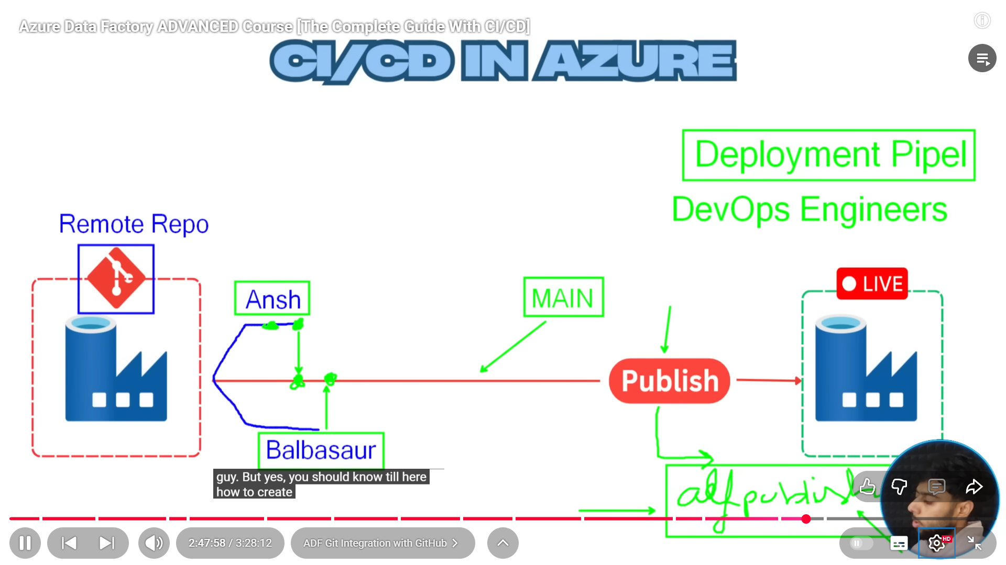
create a repo in git>
in ADF>git configuration>type>github>after configuring
we work on branches and after everything is done we save it and create a pull request and merge it to main branch
next in main branch team lead will publish all and create arm template which will have our entire development code
from there devops team will take care
===============================================================
Dataflow
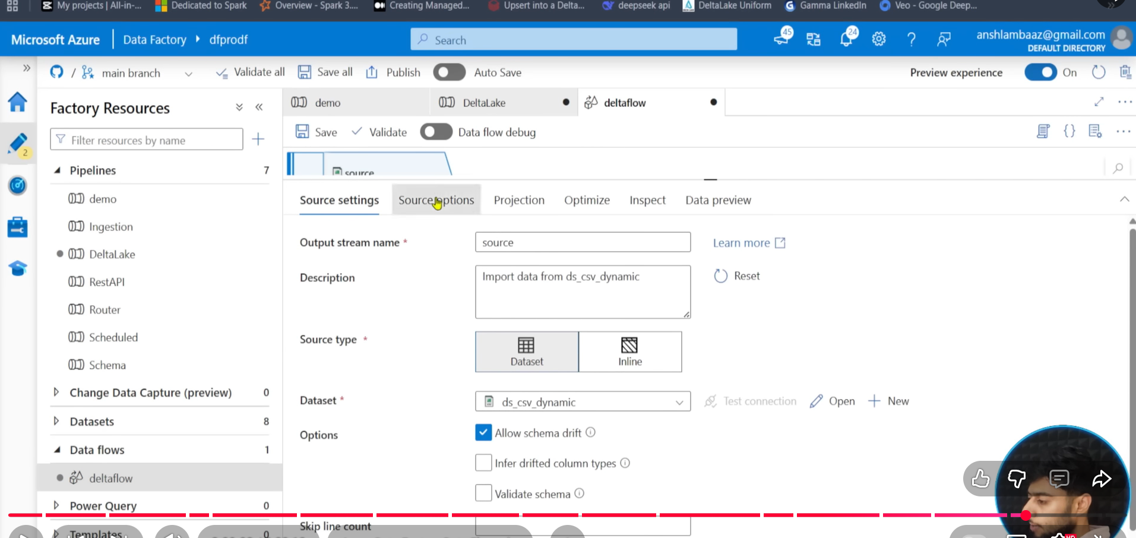
bottom down we have sampling – meaning run transformations using sample data
in bronze we use copy activity
in silver and gold we use dataflow
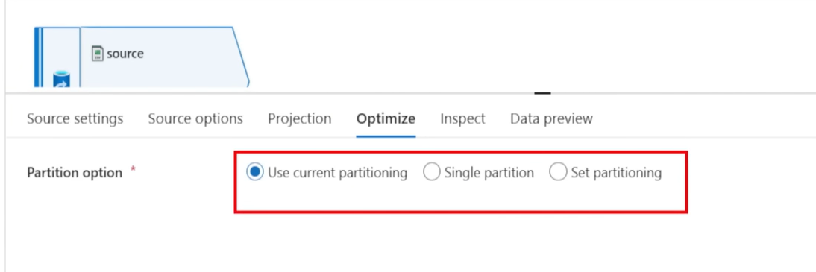
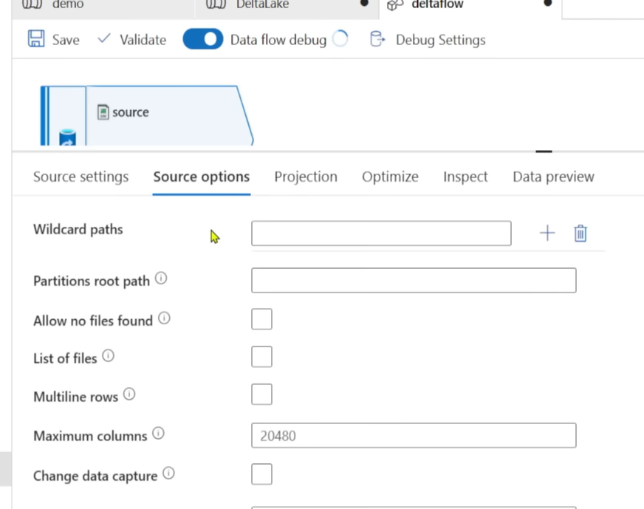
after coming into Dataflow if we want to see the columns we need to import projections in dataflow
Derived Columns will be coming from existing column
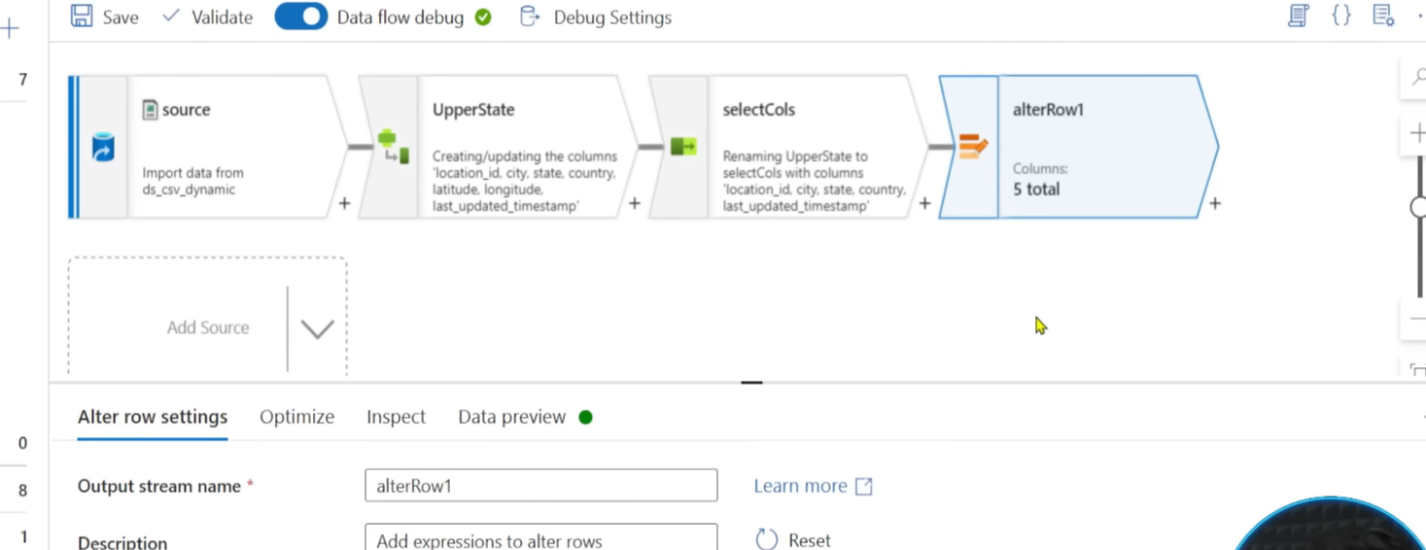
we need to user ALTER ROW at any cost, it is mandatory use UPSERT – update and insert (merge)
Now load into sink using
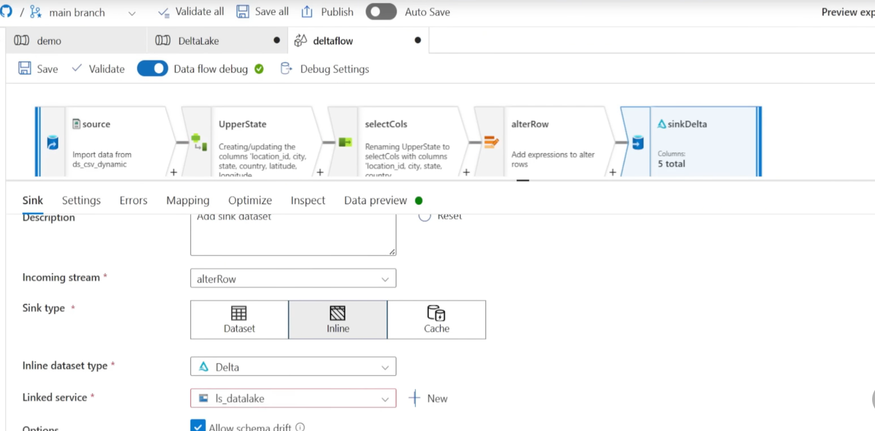s
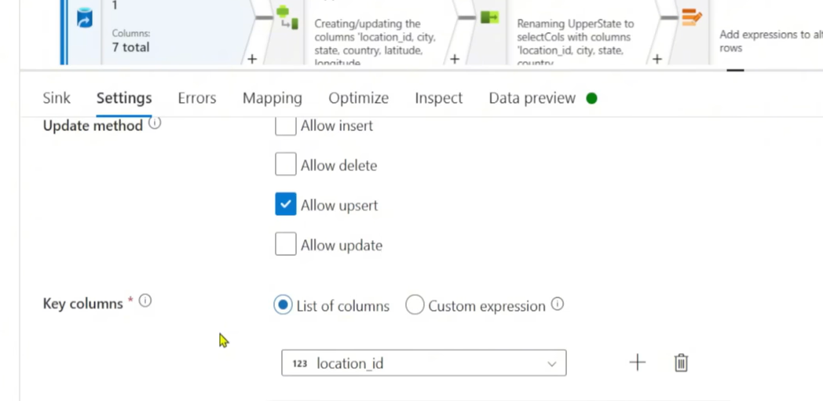
BIG DATA
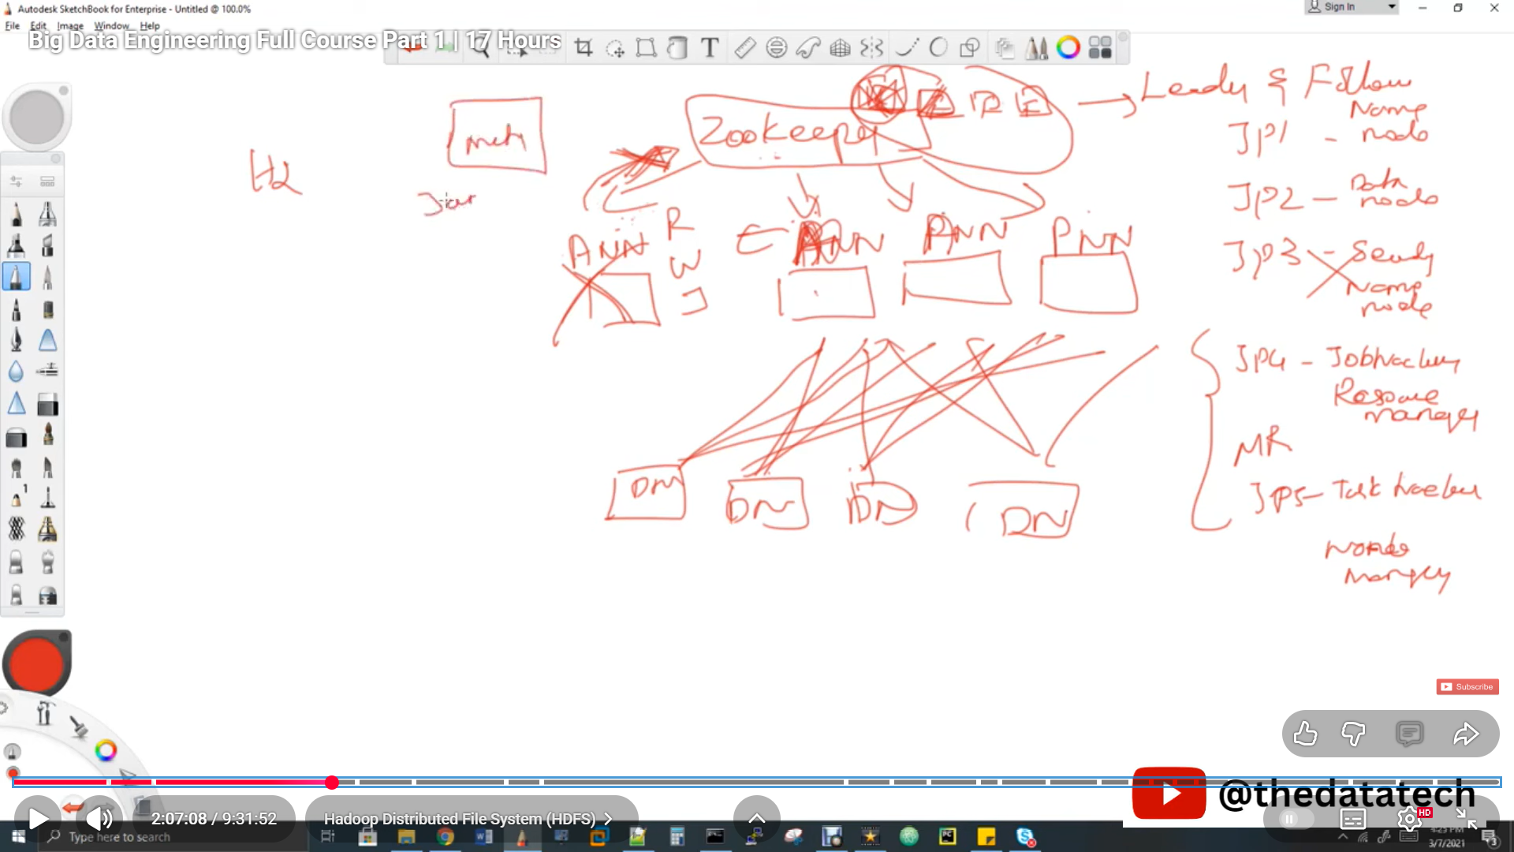
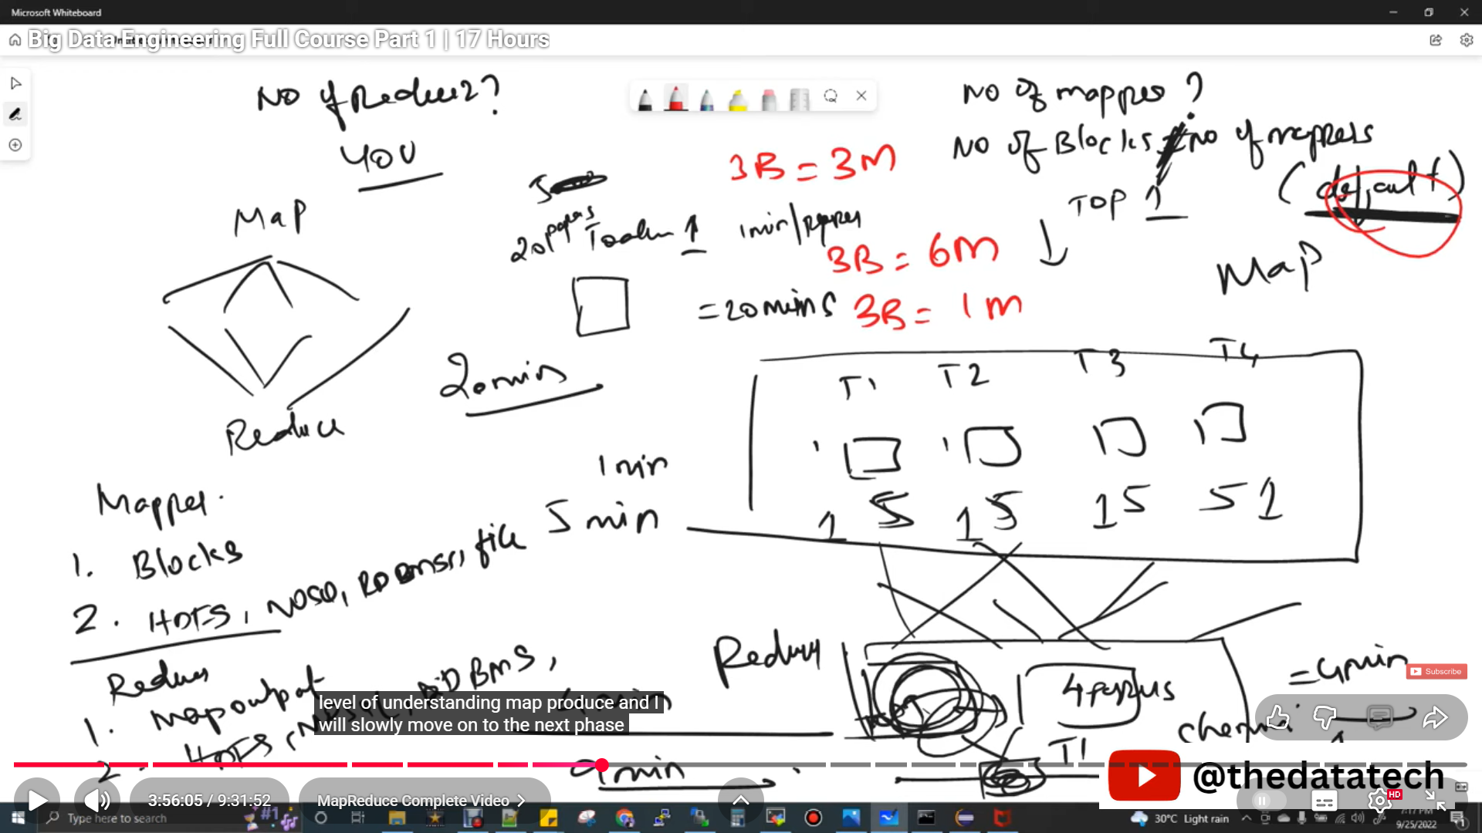
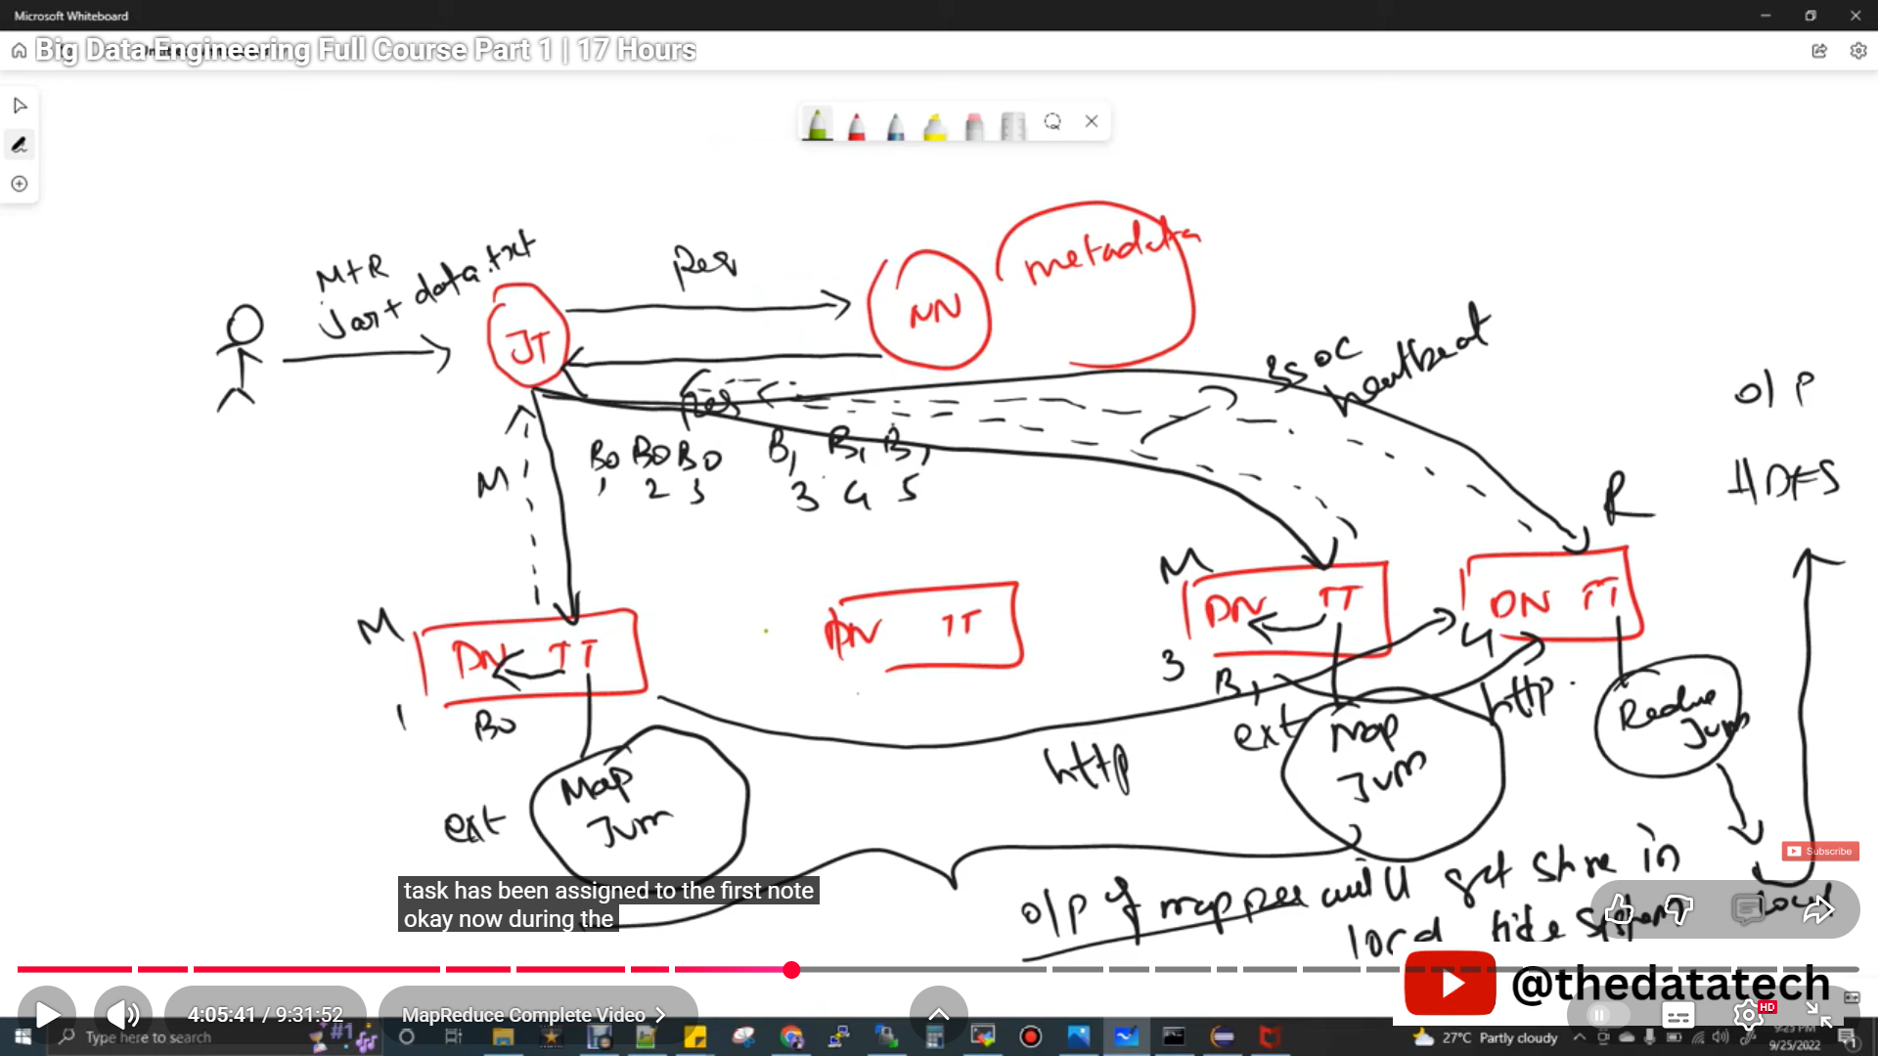
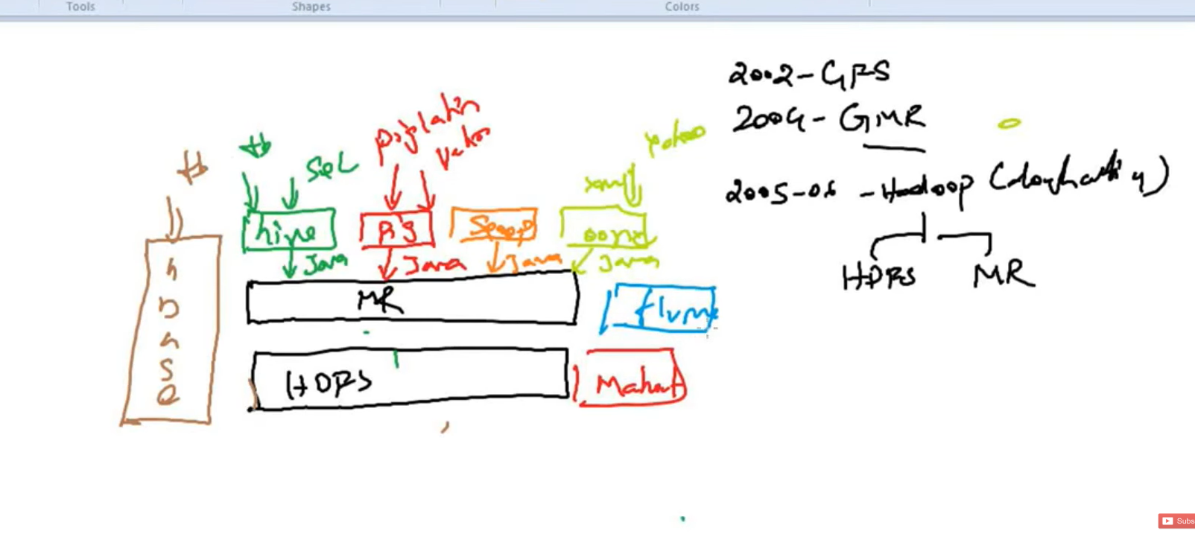
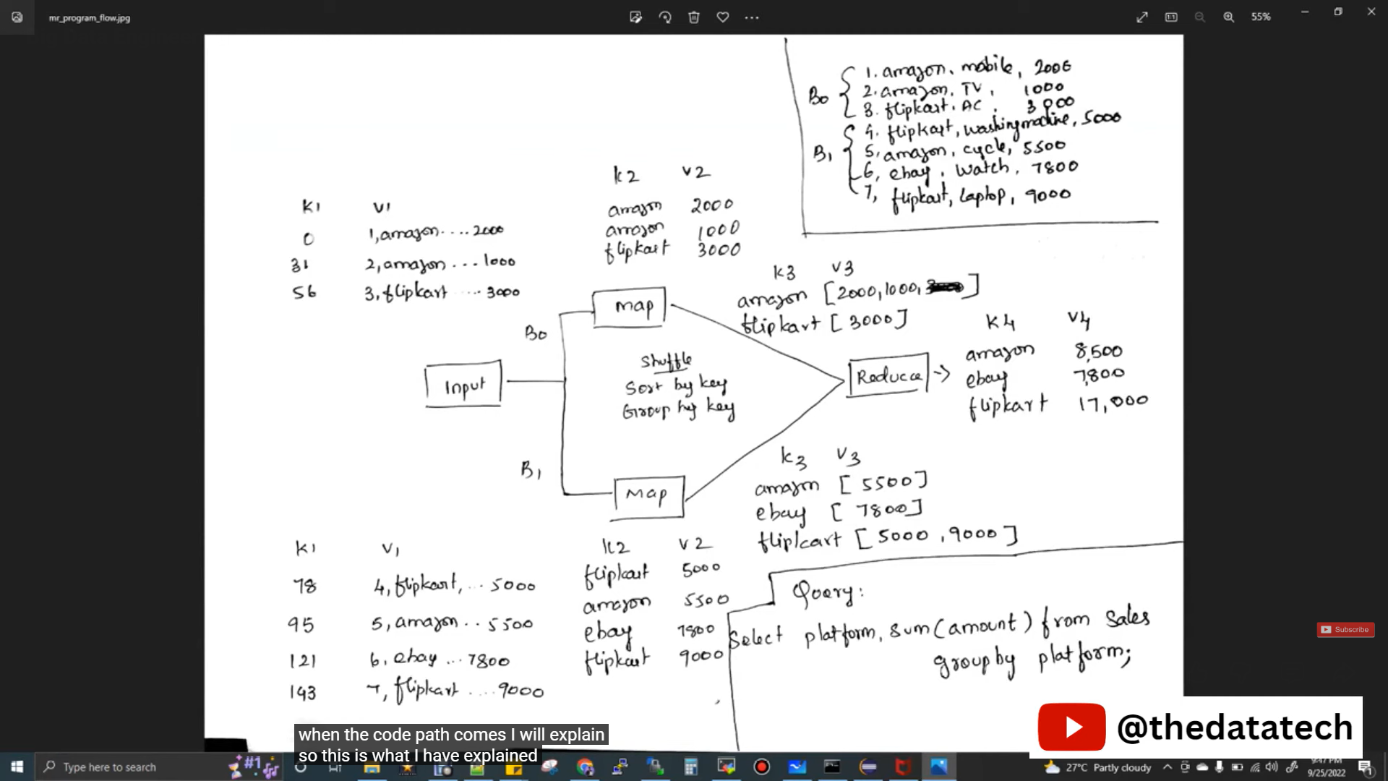
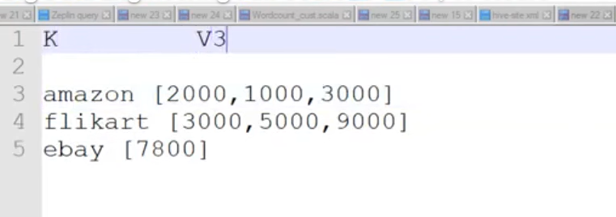
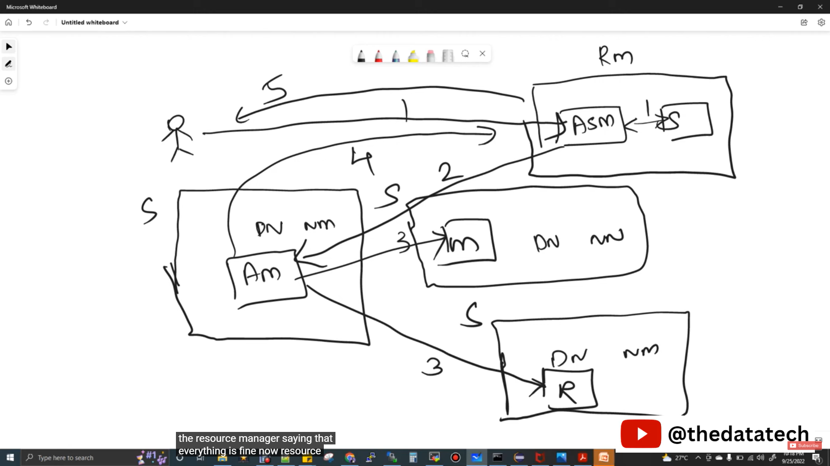
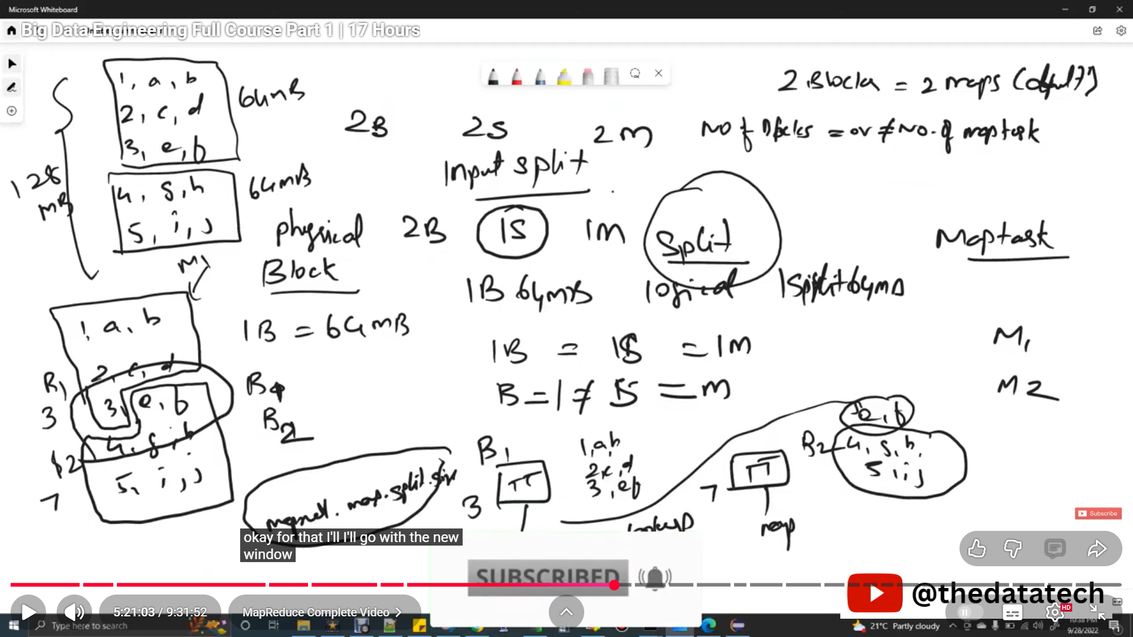
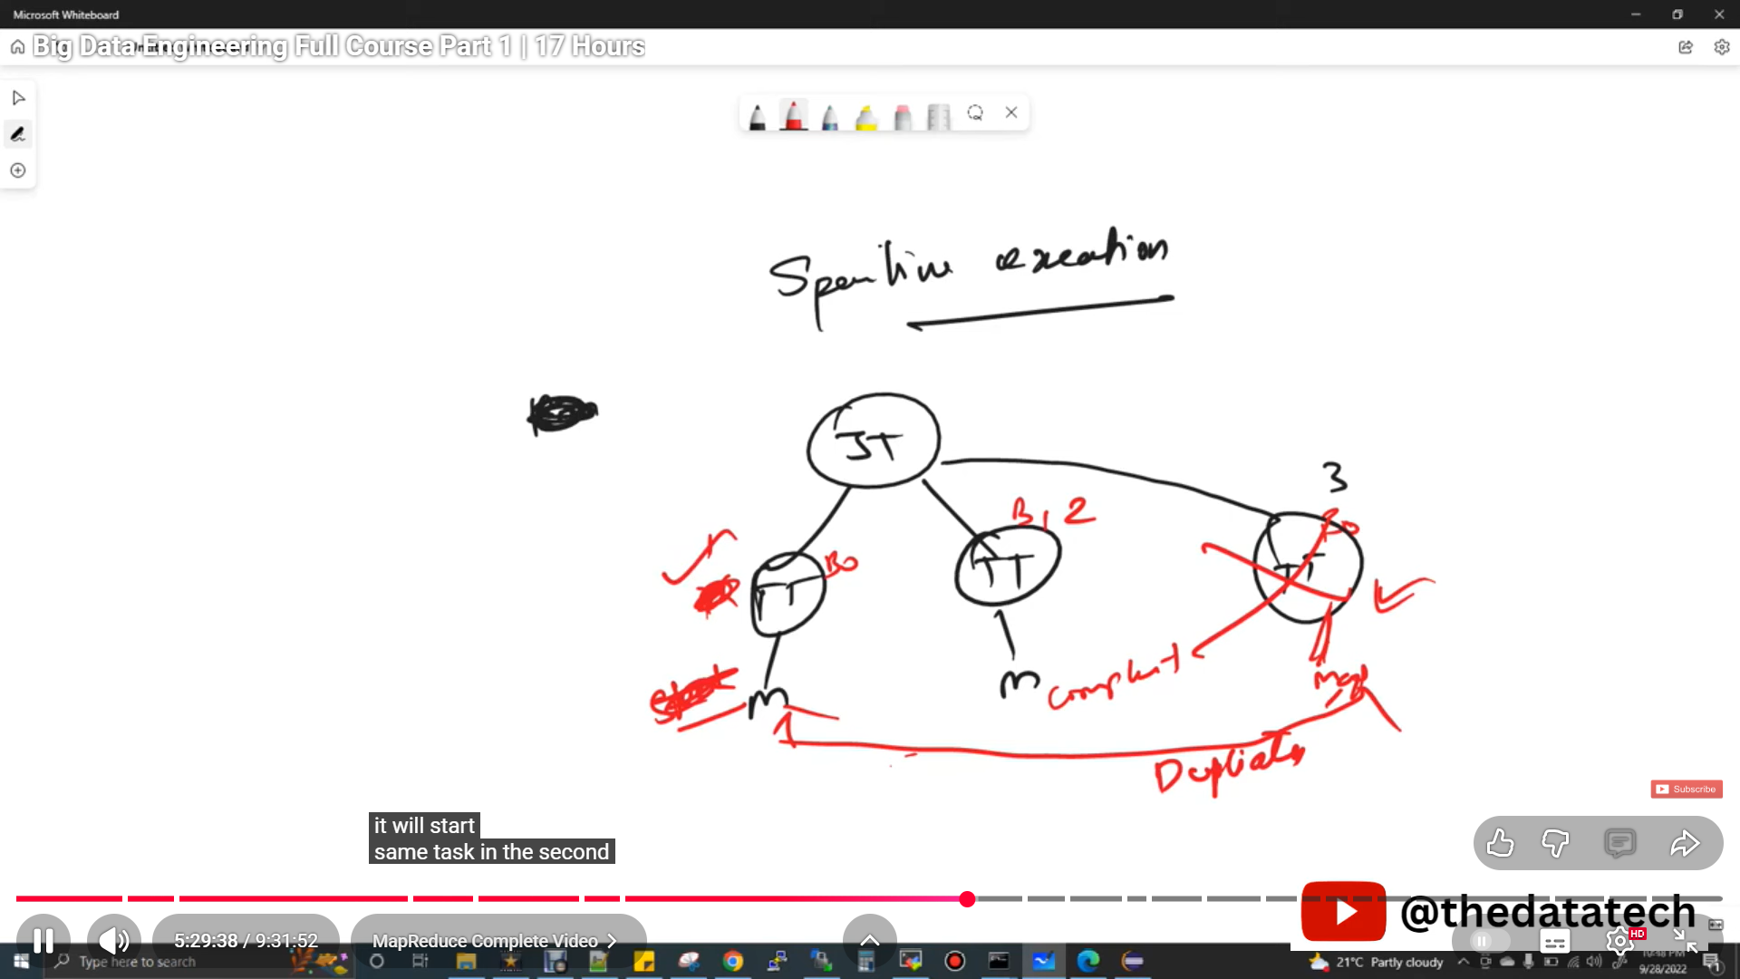
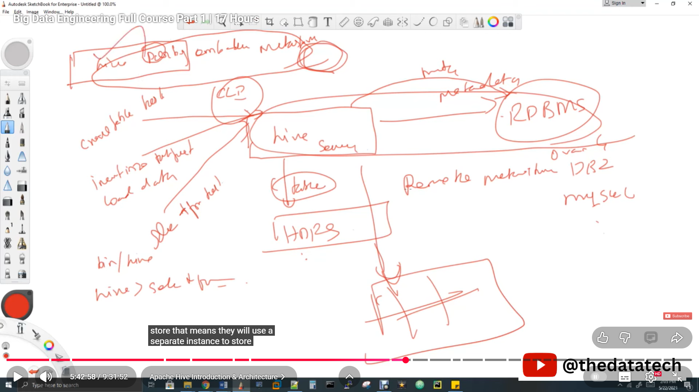
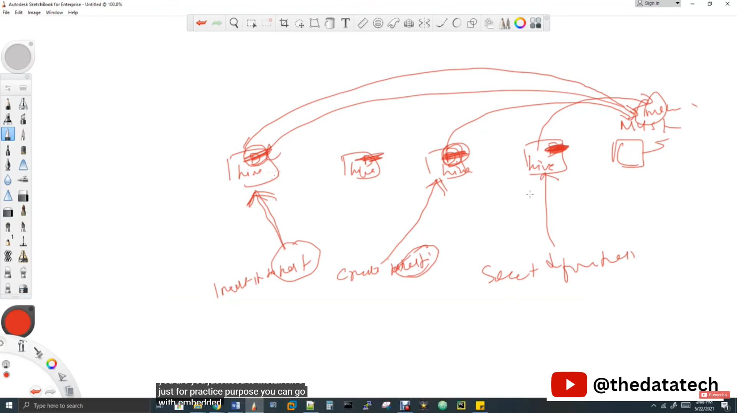
show databases;
drop database database name
create database test
show tables
create table dbname.tablename
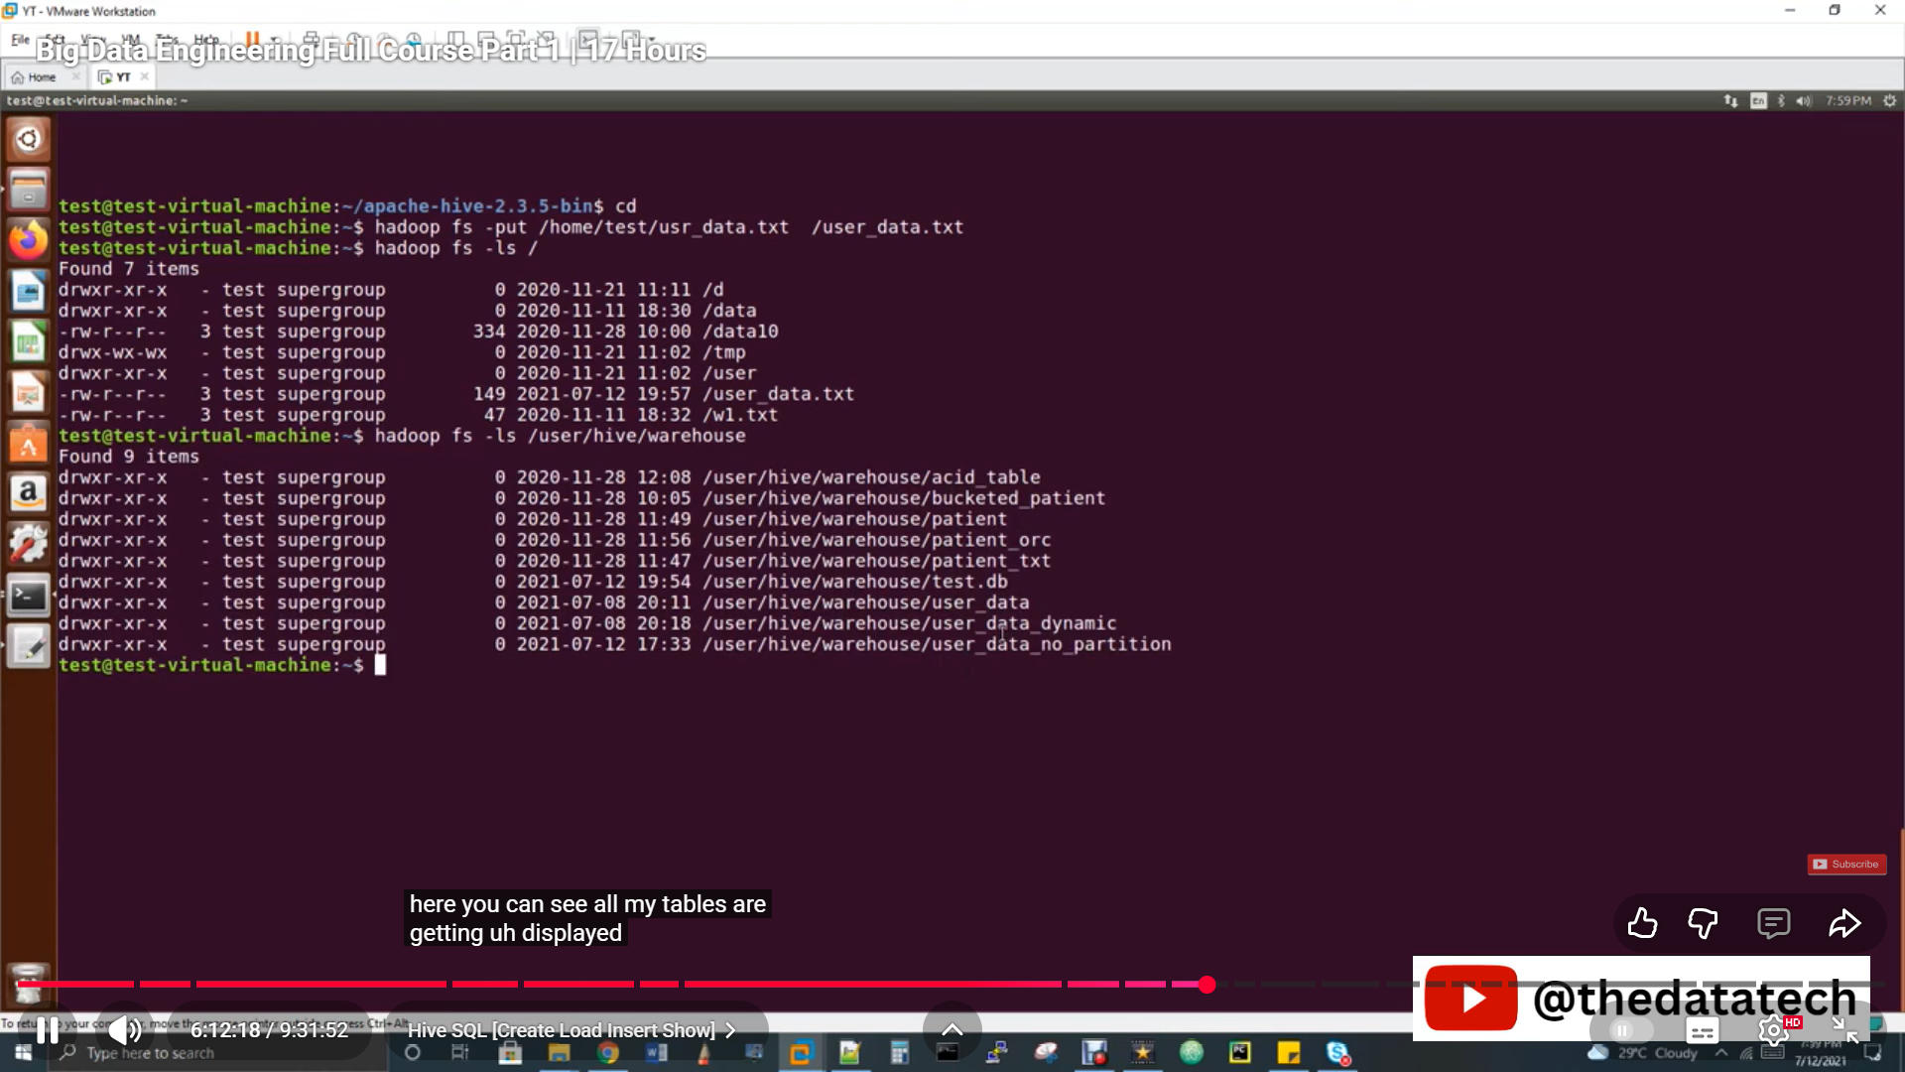
Desc tablename;-----scheme details
desc extended tablename ----complete details

